# Table of Contents

**Network-as-a-Service Runbook**

***Strategy & Scope Definition Template***

**<NaaS Operator’s Name>**

**

*<Release Date>*

Table of Contents 1

1 Document Control 3

2 About Design Template 4

2.1 Document Purpose 4

3 Executive Summary 4

4 Introduction 5

5 Research & Analysis 5

5.1 Strategic Issues & Risk Identification 5

5.2 Operating Environmental Scan 5

5.3 Telecom Industry Environment Scan 5

5.4 SWOT Analysis 6

6 Mission and Scope 6

6.1 Mission Statement 6

6.2 Vision Statement 6

6.3 Competitive Advantages 6

6.4 Technologies and Services Definition 6

7 Strategy Design 7

7.1 Organization-Wide Strategies Definition 7

7.2 Long-Term Strategic Objectives Definition 7

7.3 Set Organization-Wide Goals and Measures 8

8 Governance 8

8.1 KPI Definition 8

8.2 Establish Schedule for Progress Reviews 8

8.3 Goal Tracking Methodologies 8

8.4 Review and Adapt Process 8

# Document Control

- Revision Control sheet allows to maintain a record of changes made on the document.

|  |  |  |  |
| --- | --- | --- | --- |
| Version N° | Issue Date | Status | Reasons for Change |
|  |  |  |  |
|  |  |  |  |
|  |  |  |  |
|  |  |  |  |

Table 1. Revision History

# About Design Template

## Document Purpose

The purpose of this document is to provide a baseline document that NaaS operators can use to define the Strategy & Scope of the initiative.

The rest of the document is divided into five sections. Section 4 is an introduction of the Strategy & Scope Fundamentals as well as a high-level view of their development process. Section 5 focuses on the particular environment and market. Section 6 defines the NaaS operator’s mission and scope. Then in section 7, the overall strategies and long-term objectives are provided. Finally, Section 8 includes the procedures to control and manage the implementation and updates of the defined strategies.

In each section, the customizable options are provided with the following format. This options must be attended accordingly and deleted of the final version of the document.

# Executive Summary

The Strategy & Scope of the NaaS operator is the process of an organization deciding their corporate direction, objectives and priorities, and then aligning their resources to accomplish the actions necessary to meet them.

# Introduction

The Strategy & Scope of the NaaS operator is the process of an organization deciding their corporate direction, objectives and priorities, and then aligning their resources to accomplish the actions necessary to meet them.

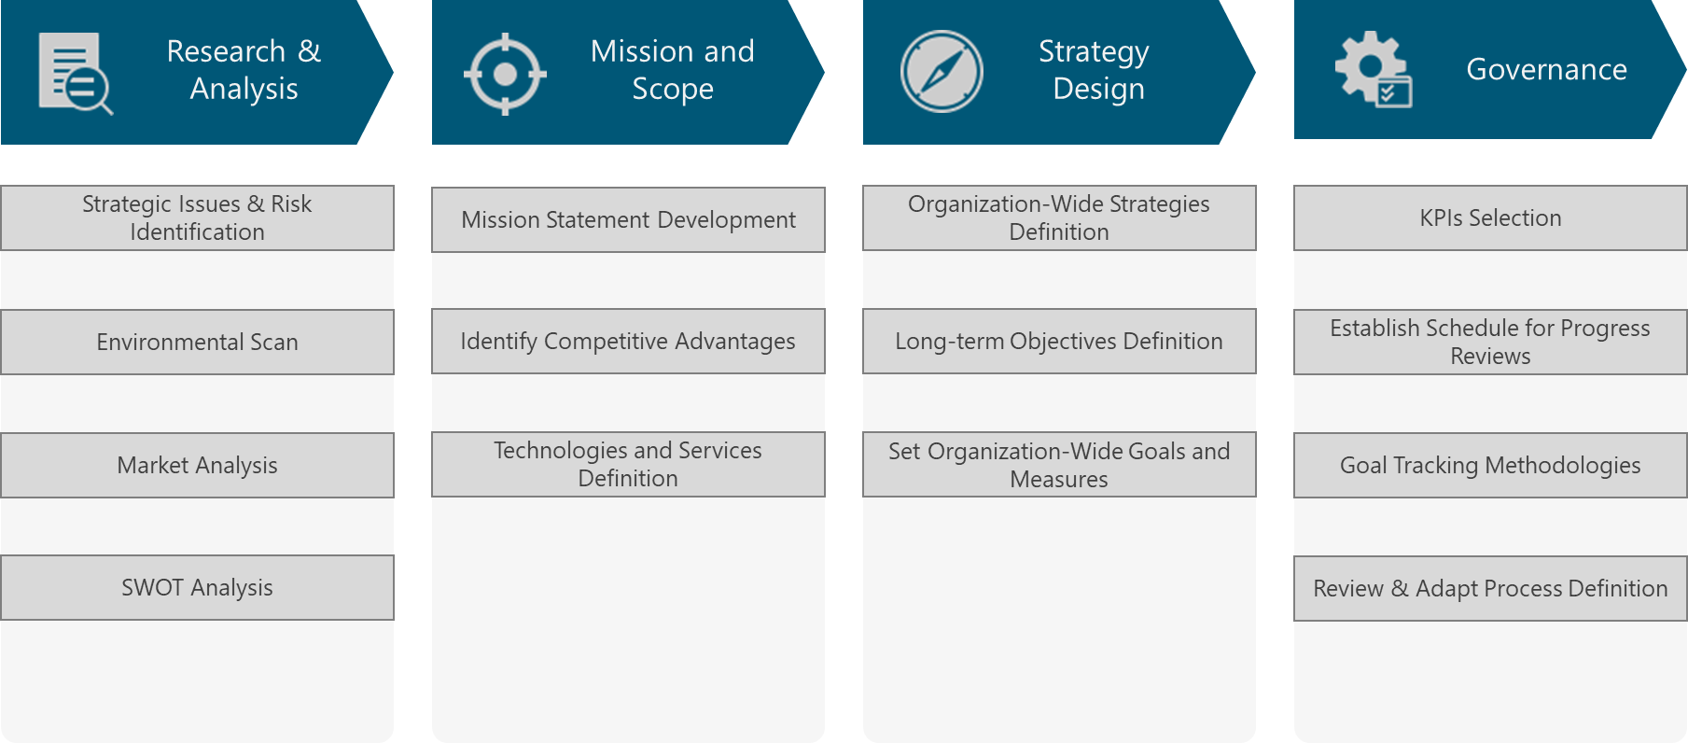

Figure XXX. Strategy & Scope Process View

# Research & Analysis

This section aims to describe procedures to examine the particular NaaS operator environment and market.

## Strategic Issues & Risk Identification

*Complement the section with the Strategic Issues identified by following the directions provided in Section 3.1 of the Strategy & Scope Module according to NaaS operator conditions.*

## Operating Environmental Scan

The operating environment, which indirectly affects the NaaS operator comprises Political, Economic, Social and Technological factors. Thus, the operating environment scan is also named as PEST analysis and is part of the Strategy & Scope process.

*Complement the section with the Operating Environmental Scan by following the directions provided in Section 3.2 of the Strategy & Scope Module according to NaaS operator conditions.*

## Telecom Industry Environment Scan

*Complement the section with the telecom Industry Environmental Scan by following the directions provided in Section 3.3 of the Strategy & Scope Module according to NaaS operator conditions.*

## SWOT Analysis

A SWOT analysis is a methodology to examine an organization by looking at the internal strengths and weaknesses in relation to external opportunities and threats. This analysis takes as an input all the previous analysis (i.e. Operating and Telecom Industry Environmental Scan, Customer Segmentation, Competitive Analysis).

*Complement the section with the result of the SWOT Analysis by following the directions provided in Section 3.4 of the Strategy & Scope Module according to NaaS operator conditions.*

*Additionally, the Naas operator can use the SWOT Analysis Template to support the development of the SWOT analysis.*

# Mission and Scope

The content of this defines the particular mission, vision and service definition for the NaaS Initiative.

## Mission Statement

*Complement the section with the Mission Statement following the directions provided in Section 4.1 of the Strategy & Scope Module according to NaaS operator conditions.*

*Additionally, the Naas operator can use the Mission Statement Assessment Checklist to assess the criteria on the developed mission statement.*

## Vision Statement

*Complement the section with the Vision Statement following the directions provided in Section 4.2 of the Strategy & Scope Module according to NaaS operator conditions.*

## Competitive Advantages

*Complement the section with the Competitive Advantages identified by following the directions provided in Section 4.3 of the Strategy & Scope Module according to NaaS operator conditions.*

## Technologies and Services Definition

*Complement the section with the defined technologies and services to be included as part of the catalog to be offered to customers. Follow the directions provided in Section 4.4 of the Strategy & Scope Module according to NaaS operator conditions.*

# Strategy Design

The present section describes the definition of the strategy and long-term objectives that ultimately will guide the downstream activities.

## Organization-Wide Strategies Definition

An organization-wide strategy is a general statement(s) that guides and covers a set of activities. It answers the question “how”. In this step of the planning process, the synthesized information in the SWOT analysis, the mission, vision and competitive advantages are used to develop the organization-wide strategy or strategies that will guide goal and action planning.

There are certain areas within the NaaS operator that requires the definition of a strategy that guides the decision of subsequent phases. These areas are presented in Figure XXX and are examined in the following subsections.

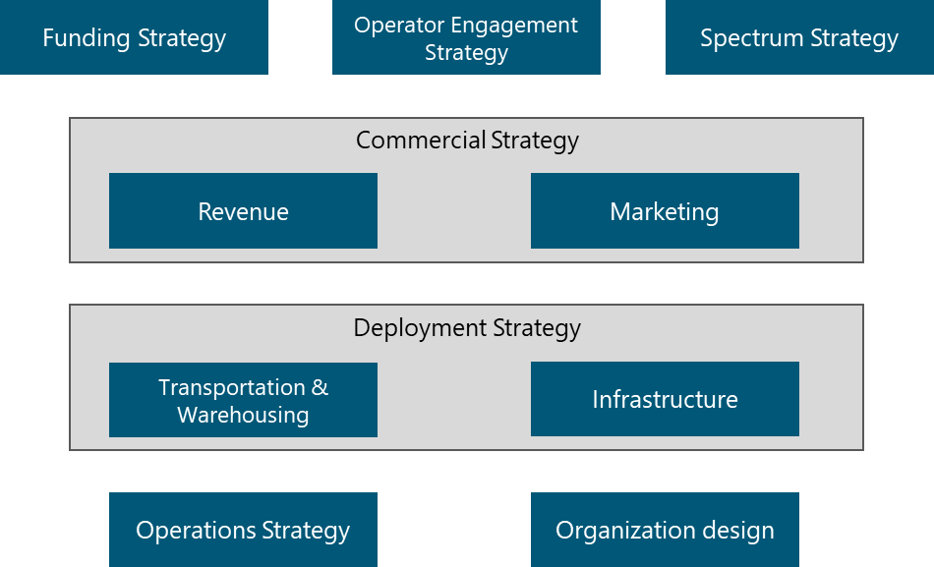

Figure XXX.. Strategy Map

*Complement the section with the definition of a strategy for each of the phases in Figure XXX. Follow the directions provided in Section 5.1 of the Strategy & Scope Module according to NaaS operator conditions.*

## Long-Term Strategic Objectives Definition

A long-term strategic objective is a long-term (e.g. 3-5 years), broad, continuous statements that holistically address the different areas of the NaaS operator. Long-term objectives that are viable and appropriate should remain as something that will not change and must be achieved.

*Complement the section with the definition of log-term strategic objectives. Follow the directions provided in Section 5.2 of the Strategy & Scope Module according to NaaS operator conditions.*

## Set Organization-Wide Goals and Measures

Once the long-term objectives have been identified, they must be translated into goals and measures that can be clearly communicated to the leadership team. Effective goals clearly state what, when, how, and who, and they are specifically measurable. They should address the tasks that need to be performed in the short-term (1-3 years) to achieve the strategic objectives.

*Complement the section with the organization-wide goals. Follow the directions provided in Section 5.3 of the Strategy & Scope Module according to NaaS operator conditions.*

# Governance

This section includes methodologies to control and manage the implementation of the defined strategies. The governance definitions aim to communicate the overall strategies as well as measure and monitor progress towards strategic targets.

## KPI Definition

Key Performance Indicators (KPIs) are the critical indicators of progress towards an intended result. KPIs provides a focus for strategic improvement and create an analytical basis for decision making.

*Complement the section with the definition of KPIs. Follow the directions provided in Section 6.1 of the Strategy & Scope Module according to NaaS operator conditions.*

## Establish Schedule for Progress Reviews

A Schedule for Progress Reviews defines the specific dates and communication channels to communicate with stakeholders regarding the strategic plan and the associated progress.

*Complement the section with the definition the Schedule for Progress Reviews. Follow the directions provided in Section 6.2 of the Strategy & Scope Module according to NaaS operator conditions.*

## Goal Tracking Methodologies

*Complement the section with the definition the Tracking Methodologies. Follow the directions provided in Section 6.2 of the Strategy & Scope Module according to NaaS operator conditions.*

*Additionally, the Naas operator can use the List of Strategy & Scope Tracking tools to select the tools to be implemented.*